**Hands on 1: Spring Data JPA - Quick Example**

**Software Pre-requisites**

* MySQL Server 8.0
* MySQL Workbench 8
* Eclipse IDE for Enterprise Java Developers 2019-03 R **(Since Eclipse IDE was not working properly in my system, I completed the hands on using IntelliJ IDEA)**
* Maven 3.6.2

**Create a Eclipse Project using Spring Initializr**

* Go to <https://start.spring.io/>
* Change Group as “com.cognizant”
* Change Artifact Id as “orm-learn”
* In Options > Description enter "Demo project for Spring Data JPA and Hibernate"
* Click on menu and select "Spring Boot DevTools", "Spring Data JPA" and "MySQL Driver"
* Click Generate and download the project as zip
* Extract the zip in root folder to Eclipse Workspace
* Import the project in Eclipse "File > Import > Maven > Existing Maven Projects > Click Browse and select extracted folder > Finish"
* Create a new schema "ormlearn" in MySQL database. Execute the following commands to open MySQL client and create schema.

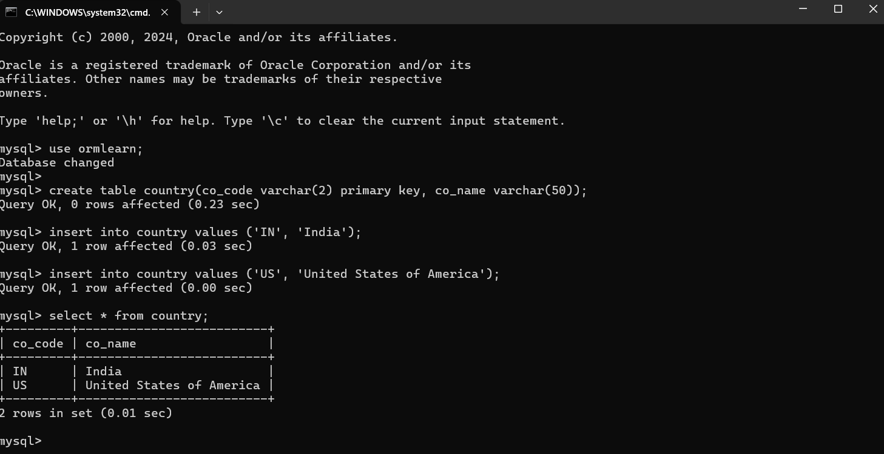

In orm-learn Eclipse project, open src/main/resources/application.properties and include the below database and log configuration.

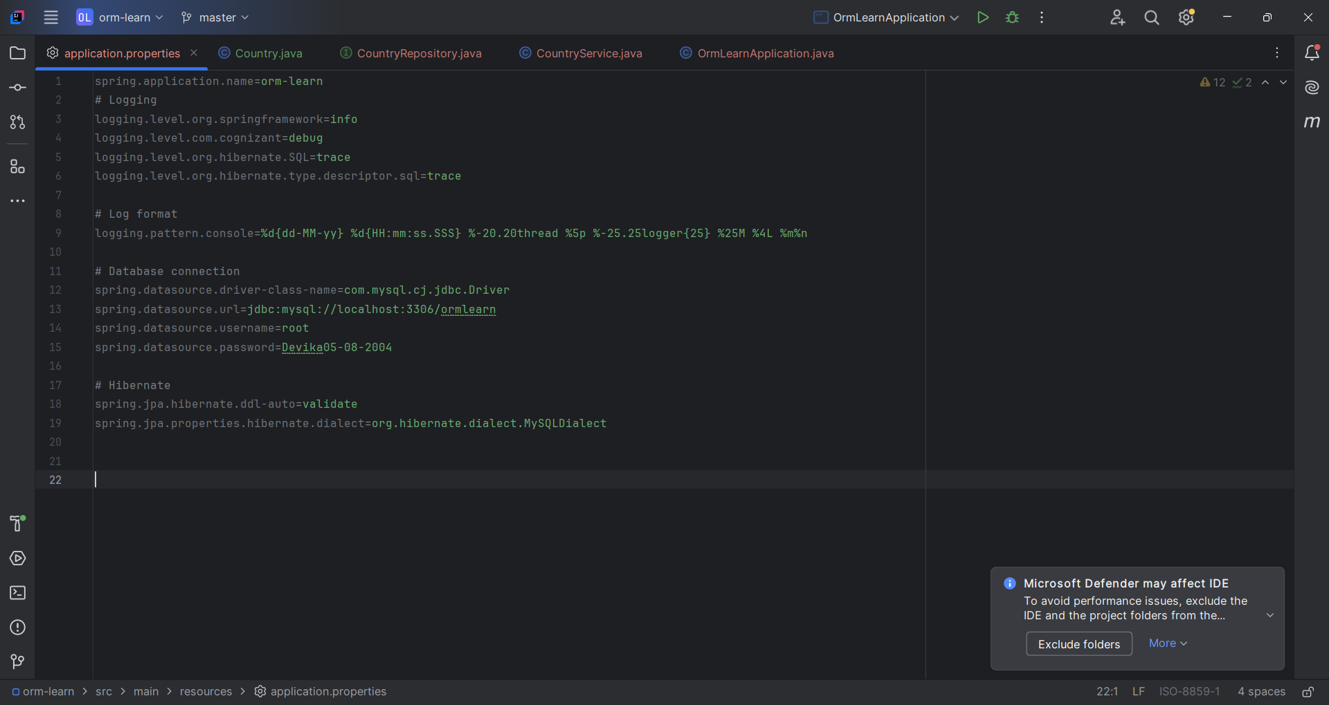

* Build the project using ‘mvn clean package -Dhttp.proxyHost=proxy.cognizant.com -Dhttp.proxyPort=6050 -Dhttps.proxyHost=proxy.cognizant.com -Dhttps.proxyPort=6050 -Dhttp.proxyUser=123456’ command in command line
* Include logs for verifying if main() method is called.

SME to walk through the following aspects related to the project created:

1. src/main/java - Folder with application code
2. src/main/resources - Folder for application configuration
3. src/test/java - Folder with code for testing the application
4. OrmLearnApplication.java - Walkthrough the main() method.
5. Purpose of @SpringBootApplication annotation
6. pom.xml
   1. Walkthrough all the configuration defined in XML file
   2. Open 'Dependency Hierarchy' and show the dependency tree.

**Persistence Class - com.cognizant.orm-learn.model.Country**

* Open Eclipse with orm-learn project
* Create new package com.cognizant.orm-learn.model
* Create Country.java, then generate getters, setters and toString() methods.
* Include @Entity and @Table at class level
* Include @Column annotations in each getter method specifying the column name.

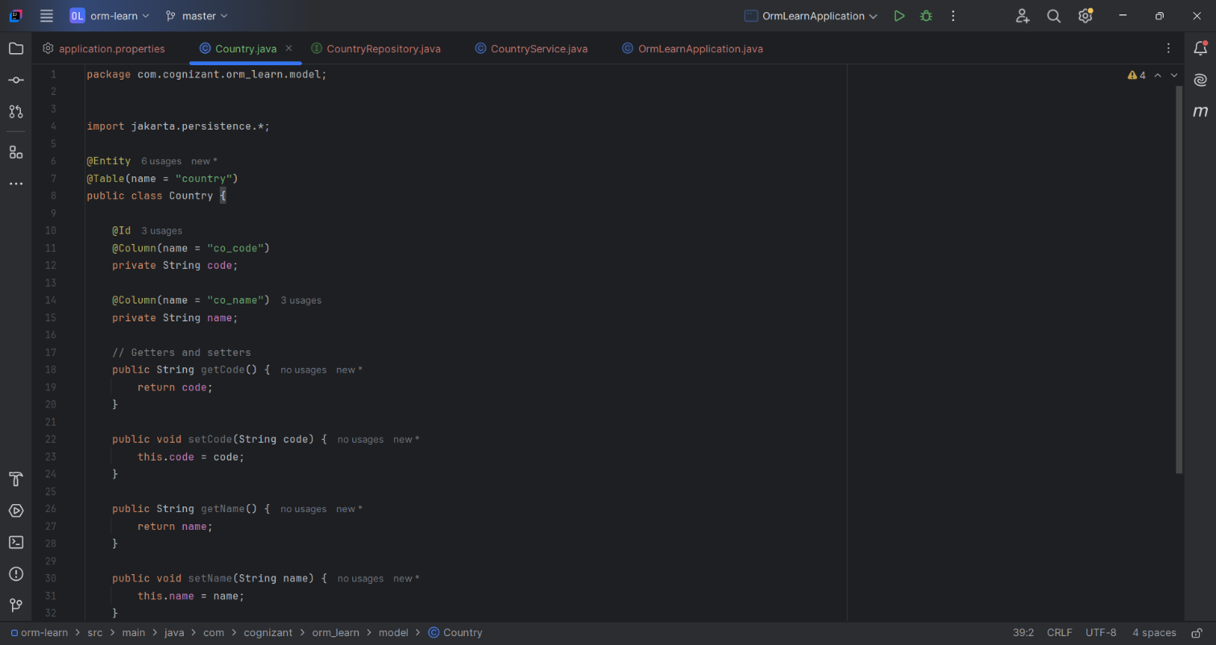

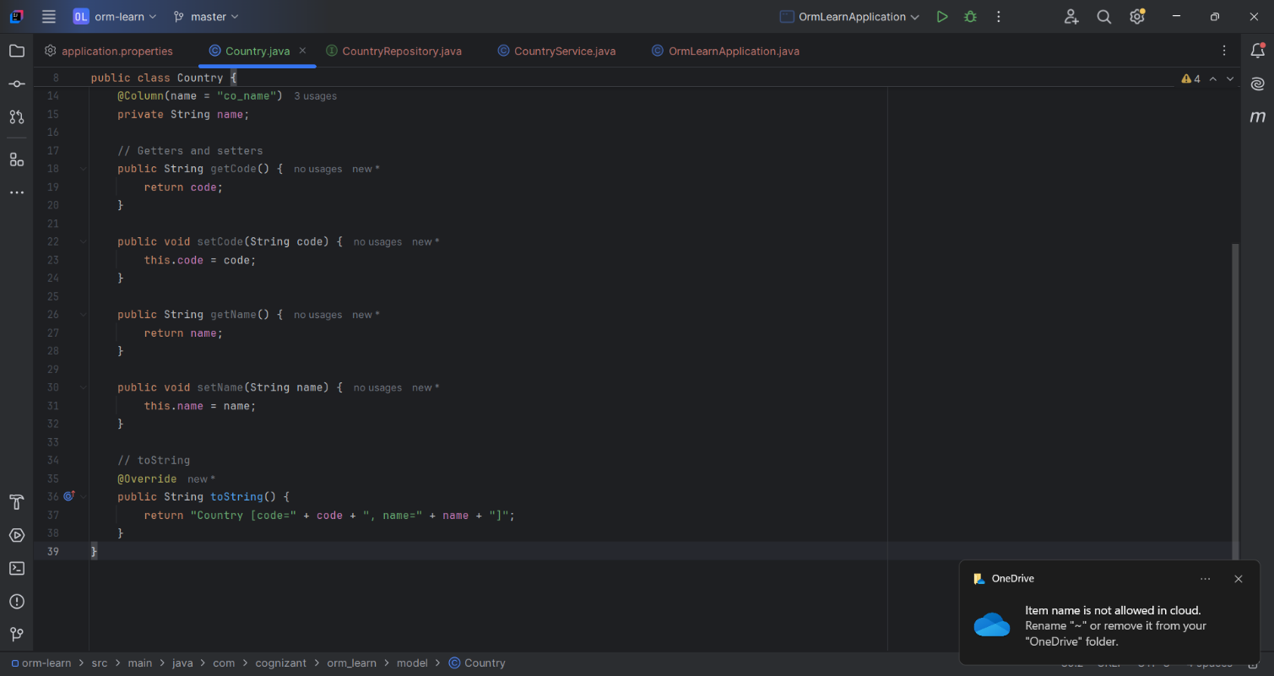

**Repository Class - com.cognizant.orm-learn.CountryRepository**

* Create new package com.cognizant.orm-learn.repository
* Create new interface named CountryRepository that extends JpaRepository<Country, String>
* Define @Repository annotation at class level

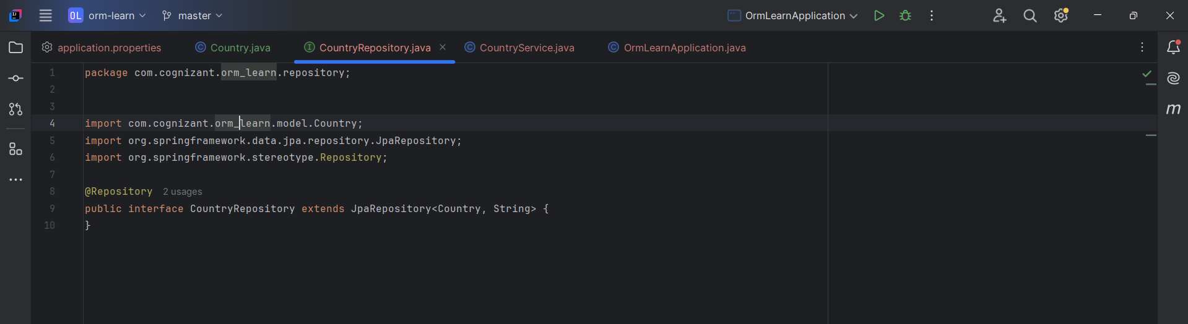

**Service Class - com.cognizant.orm-learn.service.CountryService**

* Create new package com.cognizant.orm-learn.service
* Create new class CountryService
* Include @Service annotation at class level
* Autowire CountryRepository in CountryService
* Include new method getAllCountries() method that returns a list of countries.
* Include @Transactional annotation for this method
* In getAllCountries() method invoke countryRepository.findAll() method and return the result

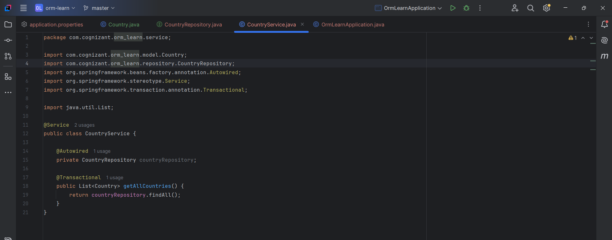

**Testing in OrmLearnApplication.java**

File content:

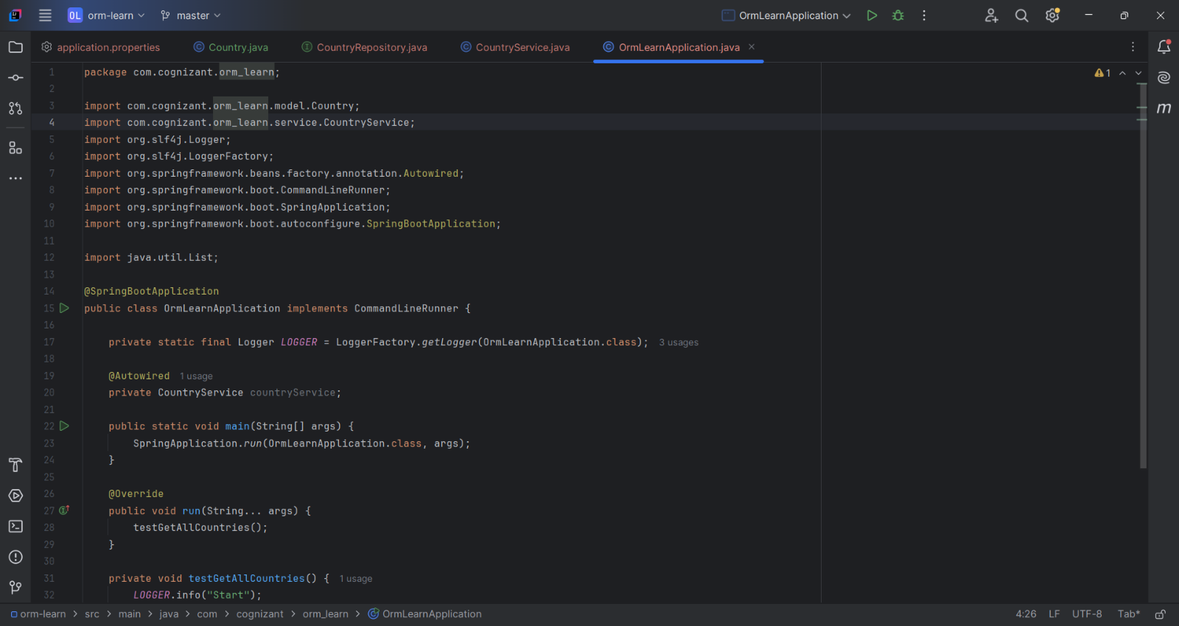

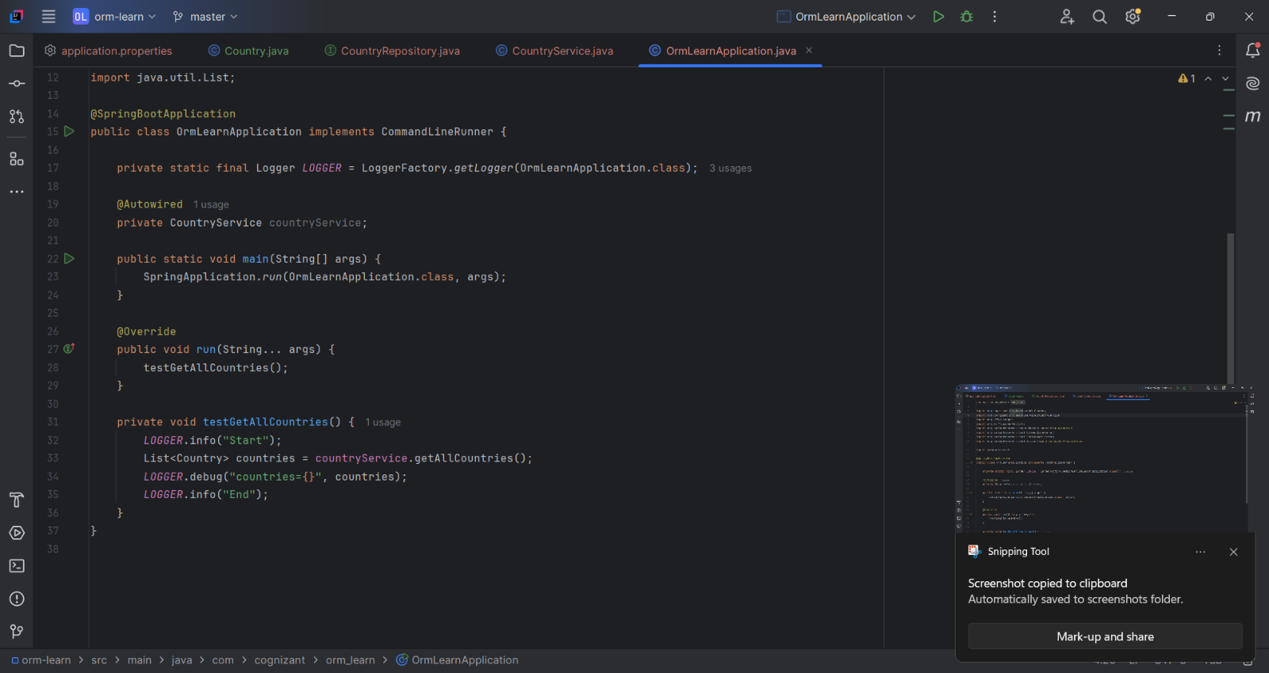

**Output:**



